Managed by Jivan Jyot Trust, Amroli-Surat
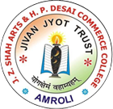
J.Z.SHAH ARTS & H.P.DESAI COMMERCE COLLEGE,AMROLI-SURAT
Grant in Aid College affiliated to Veer Narmad South Gujarat University, Surat
Re-accredited ‘B’ (CGPA 2.74) By NAAC
An ISO-9001:2015, ISO-14001:2015, OHSAS-18001:2007 Certified Institute
B.A. [Principal- Gujarati & Economics], B.Com [Eng. & Guj. Medium]
M.A. [Gujarati, Economics, English], M.Com. [Accountancy - Eng & Guj. Medium]

Reports of Seminar, Workshop and Conferences arrange by College
Year 2015-16
FOR STUDENTS
- Faculty Development program campus to cooperate by TCS(12/10/2015 to 16/09/2015)

Report of faculty development programme arrange on 12th October to 16th october ,2015 Under the banner of “Campus to Corporate” Tata Consultancy services (TCS) has organized a faculty development programme in co-operation with J. Z. Shah Arts & H. P. Desai Commerce College, Amroli & R. V. Patel College of Commerce, Amroli.
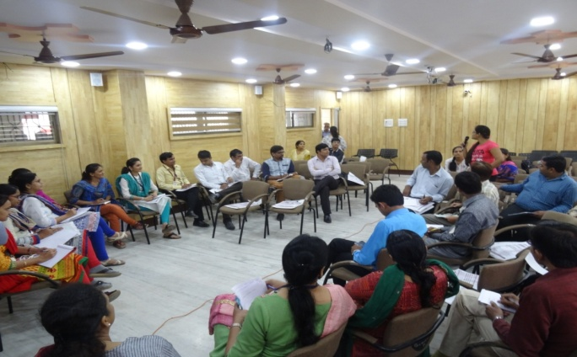
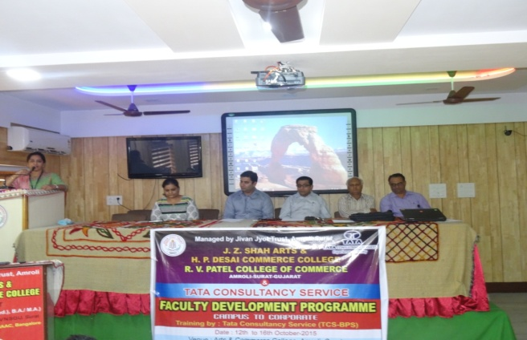
In This Programme 10 number of colleges has participated and 35 faculty members of this college have presented their colleges. During these five days programme the faculty members have attained the training of communication skills, E-mail etiquettes, telephone communication, interview preparation, C.V. writing, Project presentation, management games, etc. Near about 30 participant could qualify this programme successfully. The main purpose of this programme was to train the student by the well-trained faculty members.

- TCS Affirmative Action Employability Training of SC/ST Students. 28/01 to 13/02/2016
The TATA Consultancy Services – Affirmative Action training program aims at providing Free
Employability Training to the students from SC/ST background.
This 100 hours training comprises the following curriculum:
- English communication & Grammar pertaining to practical use in the business world.
- Vocabulary
- Email etiquettes
- Soft Skills
- Resume building
- Interview facing skills
- Analytical skills
At the conclusion of 100 hours training students will receive a TCS Certificate of completion & appreciation which will increase their employability in the corporate world.
In addition, post training TCS Recruitment team will conduct a campus recruitment drive and the candidates who successfully clear TCS selection process will be selected for TCS BPS back office operations role.
To increase employability and upliftment of the SC/ST students we organized TCS Affirmative Action training program for SC/ST & other final year students collaboration with TCS from 28rd FEBUARY to13th March 2016. Total 83 students took part in it. Trainer Kiran Gathania gave 100 hours training to students. After the training in TCS campus recruitment drive 18 students were selected.
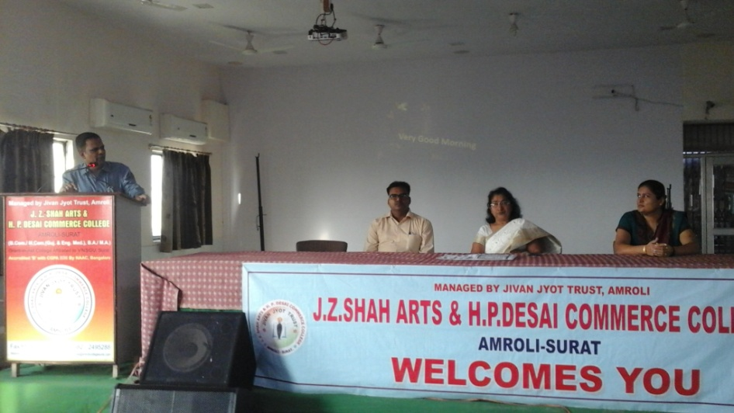
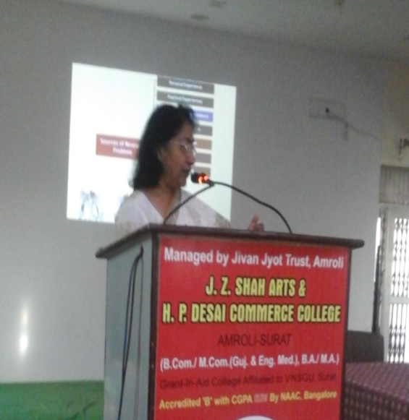
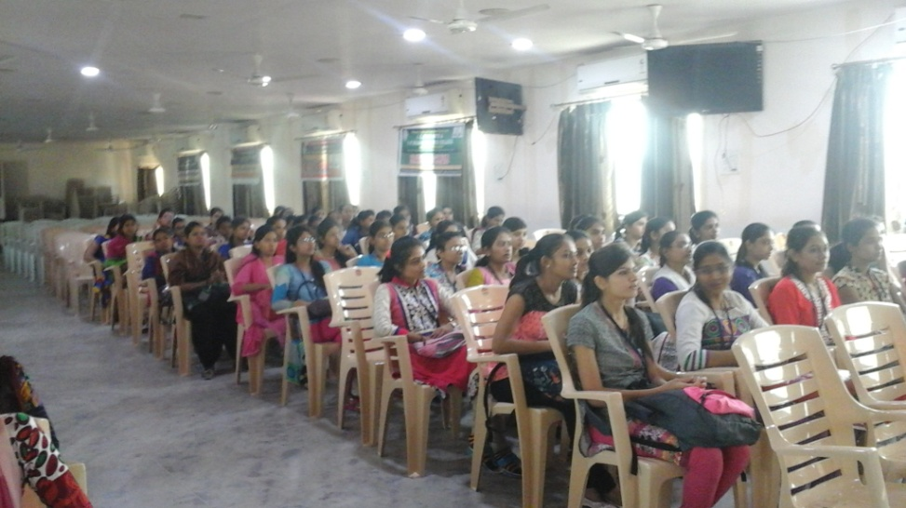

- Seminar on Research Methodology for PG Students. (3/2/2016 &5/2/2016 )
Research not only generates useful insight and confidence but also acts as a stimulant for academic growth. That’s why the college has organized two days seminar on ‘Research Methodology’. Sound conceptual understanding of various research methods, research instruments, tools and techniques is an essential prerequisite for conducting empirical research. For undergoing high quality research and writing good research papers, one requires to collect, interpret and logically document the information. The art of drawing coherent conclusions, supported by appropriate research tools and reference citation is vital for quality research work. The recent innovations in statistical applications, availability of statistical software applications allow scholars/researchers to test more complex, multilevel and dynamic models.
The key objective of this Seminar was to enable the students:
- To formulate a research proposal;
- To develop suitable Research Methods & Data Analytical Tools;
- To draw better conclusions from the analysis; and
- To write a good Research Paper.
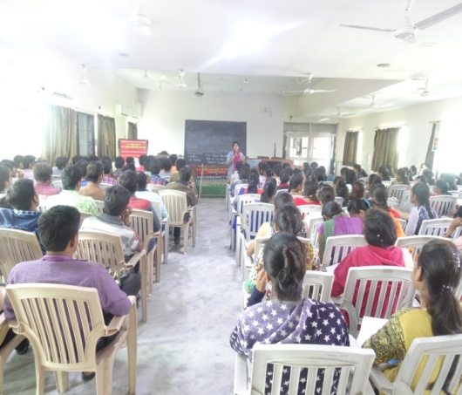
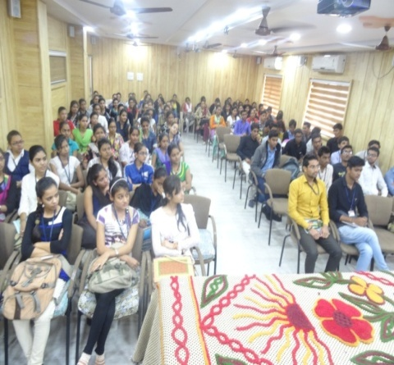
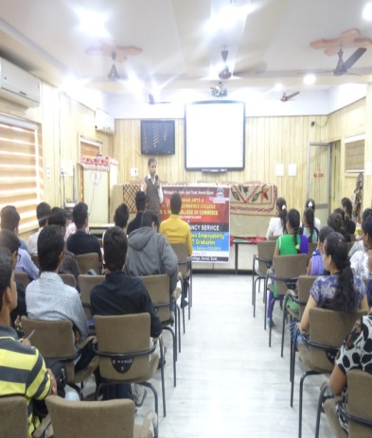
4. Organized the KCG & UDISHA ‘Soft Skill Training’ Workshop (24/2/16 to 27/2/2016)
The workshop on Soft Skill Training have been organized by the college in the sports complex of the college. The seminar was attended by 75 Students from B.Com. The motive of the seminar was to make the students aware of the forthcoming Training Sessions. Students got a thorough understanding of the schedule of the sessions. The session opened with prayer, lightening of lamps and introducing the guest faculties. The speaker found serious skills gap & shortage in the industries of Surat, which were evident through various surveys & statistics. Information was disseminated regarding the industry specific soft skills that the ever competitive industry demands. Along with explaining the importance of how Soft Skills play an important role in professional life, The speaker also explained how to impart the training for acquiring the same. He illustrated how acquiring these skills are crucial for professional as well as personal development. The entire session being very interactive, students took active part in understanding the topic. Students absorbed the information & shared their experiences on the issue. The speaker, with his own experiences, shed light on the various issues faced during various stages of Professional life & how to overcome them, which was received with applause by the students.
5. Workshop on Tai-Chi (Martial and Meditation Program) for students (9/2/2016 to 13/2/2016)
Tai chi is commonly referred to as moving meditation. Tai chi’s slow, graceful movements can be used as a meditation to provide relaxed focus, to quiet the monkey mind and to engender a deep sense of relaxation that helps release inner tensions.
The key objective of this Workshop was to enable the students:
- To improves balance of mind, body and spirit.
- Improving balance, flexibility and muscle
- Strength Reducing falls in older adults
- Improving sleep quality
- Reducing anxiety and depression
Around 100 Students have participated in the workshop.

