Managed by Jivan Jyot Trust, Amroli-Surat
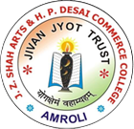
J.Z.SHAH ARTS & H.P.DESAI COMMERCE COLLEGE,AMROLI-SURAT
Grant in Aid College affiliated to Veer Narmad South Gujarat University, Surat
Re-accredited ‘B’ (CGPA 2.74) By NAAC
An ISO-9001:2015, ISO-14001:2015, OHSAS-18001:2007 Certified Institute
B.A. [Principal- Gujarati & Economics], B.Com [Eng. & Guj. Medium]
M.A. [Gujarati, Economics, English], M.Com. [Accountancy - Eng & Guj. Medium]

Reports of Seminar, Workshop and Conferences arrange by College
YEAR 2014-15
1. Workshop on csonsumer protection and consumer welfare for coordinator of consumer club (31/10/2014 to 1/11/2014)
Dr. Suresh Mishra, Chair Professor at CCS, IIPA, New Delhi, Dr. Mamta Pathania, Assistant Professor at CCS, IIPA, New Delhi, Dr. C.D. Selat, Municipal Commissioner-Food & Drugs Department, Surat, Mr. N. D. Patel, Chief Enginner (G.L.) Dakshin Gujarat Vij Company Ltd. , Surat and Dr. Girish N. Rana were the Key note speakers at the workshop. Prin. Dr. K. N. Chavda was the inspiring lead behind this. Mr. Mayank V.Sodha and Ms. Shobhana P. Chhapia offered their services as comperes at the workshop. The welcome speech was delievered by Mr. Pratap V. Chhapia, President of South Gujarat Consumer Protection Education and Research Centre. Ex- Member of Parliament, Shri Ramjibhai Mavani & Smt. Ramaben R. Mavani also graced the occasion with their presence.
At the workshop focus was on Consumer protection Act, 1986, procedure of filing complaints, consumer clubs, Role & Responsibilities of a Co-ordinator, Consumer Rights [Sec. 6 C.P Act], importance of consumer awreness, Advertisement and Food safety, Measures to be taken to differentiate between original and duplicate food and drugs product, Electricity & Consumer Protection and Banking and Insurance Sector and Consumer Education.
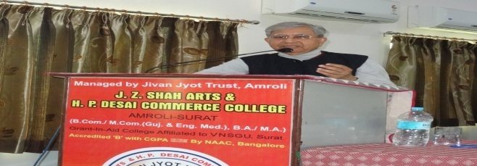
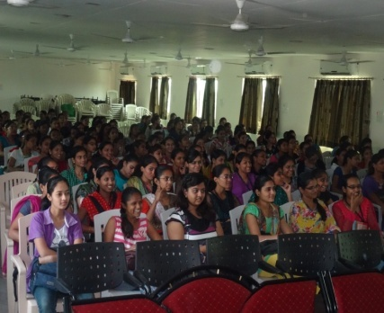

2. Workshop on new direction in education in collaboration with osho lotus charitable trust (23 & 24/12/2014)
A two day workshop was hosted by the institute in the auditorium of V.T. Choksi, B.ED. College, Surat. The workshop was conducted by Dr. Vasant Joshi (Swami Satya Vedant), the Ex-Chancellor of Osho Multiversity and Dr. Nidhi Rastogi (Ma Prem Nidhi). The workshop was attended by 310 participants from the field of Education including 12 Principals, 153 Professors, 91 school teachers and 54 students. The co-ordinator of the workshop Mr. Ajit R. Naik presented the biography of Osho, his love for books and the way he could absorb near about ten books in a day. Dr. K. N. Chavda remained a strong support in the co-ordinator of the back stage activities.
First, Session was devoted to the theme of the workshop and it focused on new direction in education as in Osho’s vision. The second session was followed by Dr Nidhi Rastogi’s talk on the Limitations of Present Day Education system & the creative ways to bring about effective changes. The third session was mainly interactive and the last session was devoted to imparting education through meditation.

3. Workshop on spiritual parenting in collaboration with osho lotus charitable trust (25/12/2014)
One day workshop was conducted only for the parents on the Christmas Day. The workshop was led by Dr. Nidhi Rastogi (Ma Prem Nidhi). She tried to focus on the need to allow the children to make mistake. Her talk was basically based on the need for freedom and self learning.
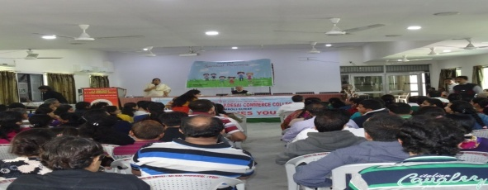

4. Seminar on C.A. and courses after B.COM key note speaker Mr. Jay Chhaira (19/9/14)
The Seminar on C.A. and courses after B.Com. was conducted by the key note speaker Mr. Jay Chhaira for the final year students of the college. The speakers briefed the students of Amroli College about various career options available after graduation. The scope of different fields available for post graduation was discussed. The students got aware about the various ways of developing their personality so as to enter the competitive corporate world. Overall it was a session that gave students idea about how to go well in planning their career.
